Name – Akshit Patel
ID – 2018A8PS0094P

Lab 1 – Design a PID controller for speed controller of DC shunt motor

Motor Parameters Taken:
Parameter | Value (in model) | Description
Moment of Inertia of Rotor (J) | 4.88145e-4 kg-m^2 | Measure of rotor’s resistance to change in rotation rate.
Damping Friction (B) | 5.1515e-3 N-m-s | Measure of dynamic friction
Torque Constant (Kt) | 0.2969 N-m/Amp | Determines motor’s required current for a given torque output
Back emf constant (Ke) | 0.1546 V/rad/sec | Change in voltage per unit change in angular speed
Stator Resistance (R) | 0.155 ohm | Per phase stator Resistance. Used in calculation of power dissipated
Armature Inductance (La) | 0.5 H | Per phase stator inductances. Determines time required to switch on motor meaning time required for current to flow in circuit

Final Transfer function -
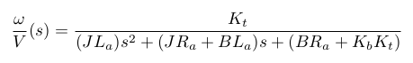

Using MATLAB damp(tf) we get to know that in our case this transfer function have zeta value of 0.3570 which means that our system is underdamped. So definitions will be used accordingly

OBSERVATIONS -
- With SIMULINK -
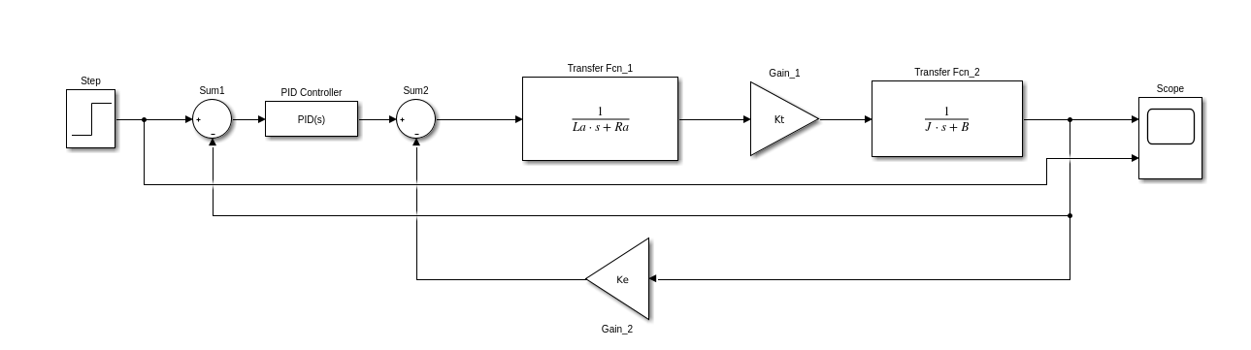

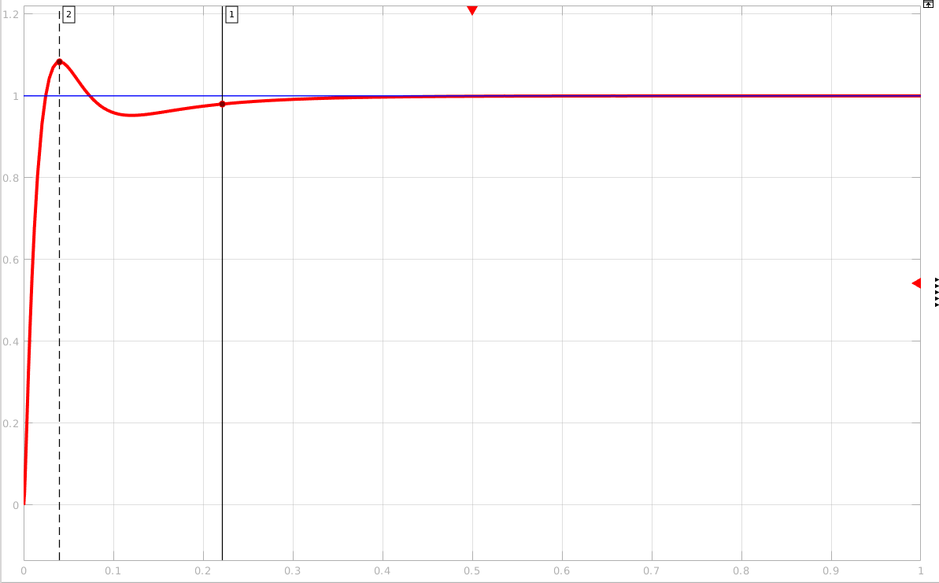
PID parameters:
Parameter | Value (in model) | Description
Proportional Gain (Kp) | 4.1965 | The proportional term produces an output value that is proportional to the current error value.
Integral Gain (Ki) | 35.8889 | The integral in a PID controller is the sum of the instantaneous error over time and gives the accumulated offset that should have been corrected previously.
Derivative Gain (Kd) | 0.1197 | The derivative of the process error is calculated by determining the slope of the error over time and multiplying this rate of change by the derivative gain Kd.

Time Domain parameters:
Parameter | Value (from graph) | Description
Rise time (tr) | 0.025 | In our case its underdamped so rise time will be time it takes for the response to rise from 0% to 100% of the steady-state response.  NOTE  (but PID tuner in simulink shows it 0.0168s as it considers 10% to 90% irrespective of type of system )
Settling time (ts) | 0.222 | Time it takes for the error |y(t) - yfinal| between the response y(t) and the steady-state response yfinal to fall to within 2% of yfinal.
Peak Overshoot (Mp) | 0.08 | deviation of the response at peak time from the final value of response

b.) With MATLAB code -

Step Response of transfer function with PID control with MATLAB code and same PID constants
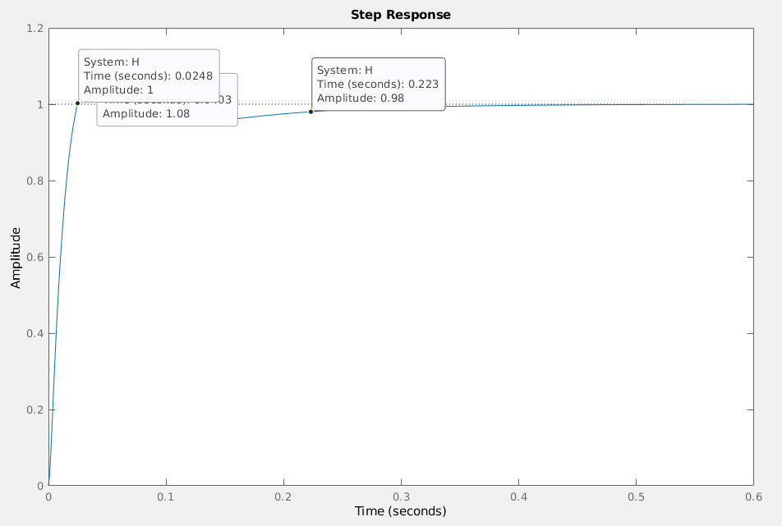

1. ) Settling Time – 0.223
2.) Rise Time -
a. Using original definition of 0 to 100% for underdamped system – 0.0248
b. As mentioned previously that MATLAB uses common definition from 10% to 90% - 0.017
3.) Peak Overshoot - 0.08

RESULTS -
1.) Same results are obtained with MATLAB and SIMULINK Code
2.) Kp Ki Kd = [4.1965 35.8889 0.1197]
3.) a.) Settling Time = 0.22 b.) Rise Time = 0.025 c.) Peak Overshoot = 0.08

